Task Title: Find Meeting Agenda and Complete Full Board Reviews for your assignments
Audience: IRB Members
Scope: Provides instructions on how IRB Members locate meeting agendas, Full Board Reviewer Worksheets and access IRB Submission forms and attachments.
Step | Action | Result/Comments
1 | Log into Insight and open the Humans module. | The Humans module can be opened by either method denoted below:  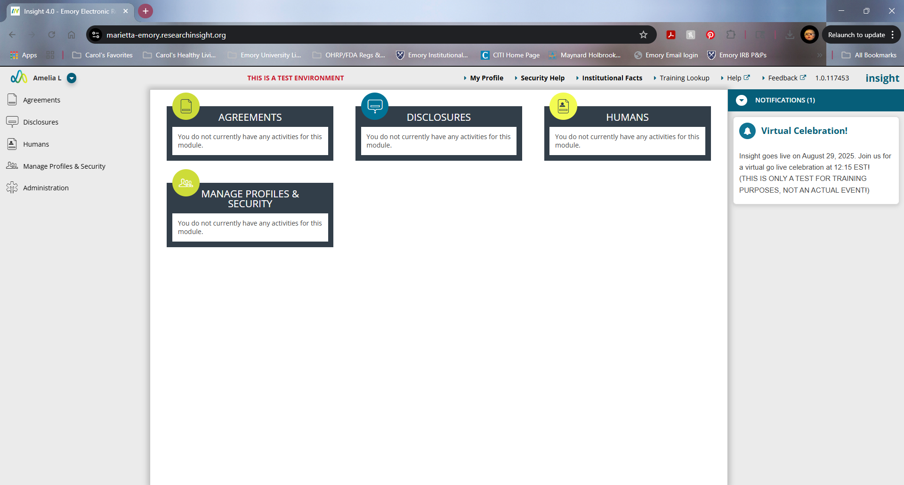
2 | Click on Members on the left menu and then detail. | 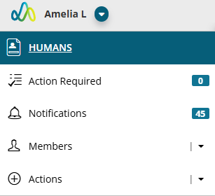
3 | Scroll down to “My Meetings” and click | Will bring you to a window labeled “My Meetings.”  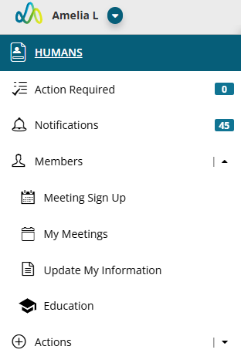  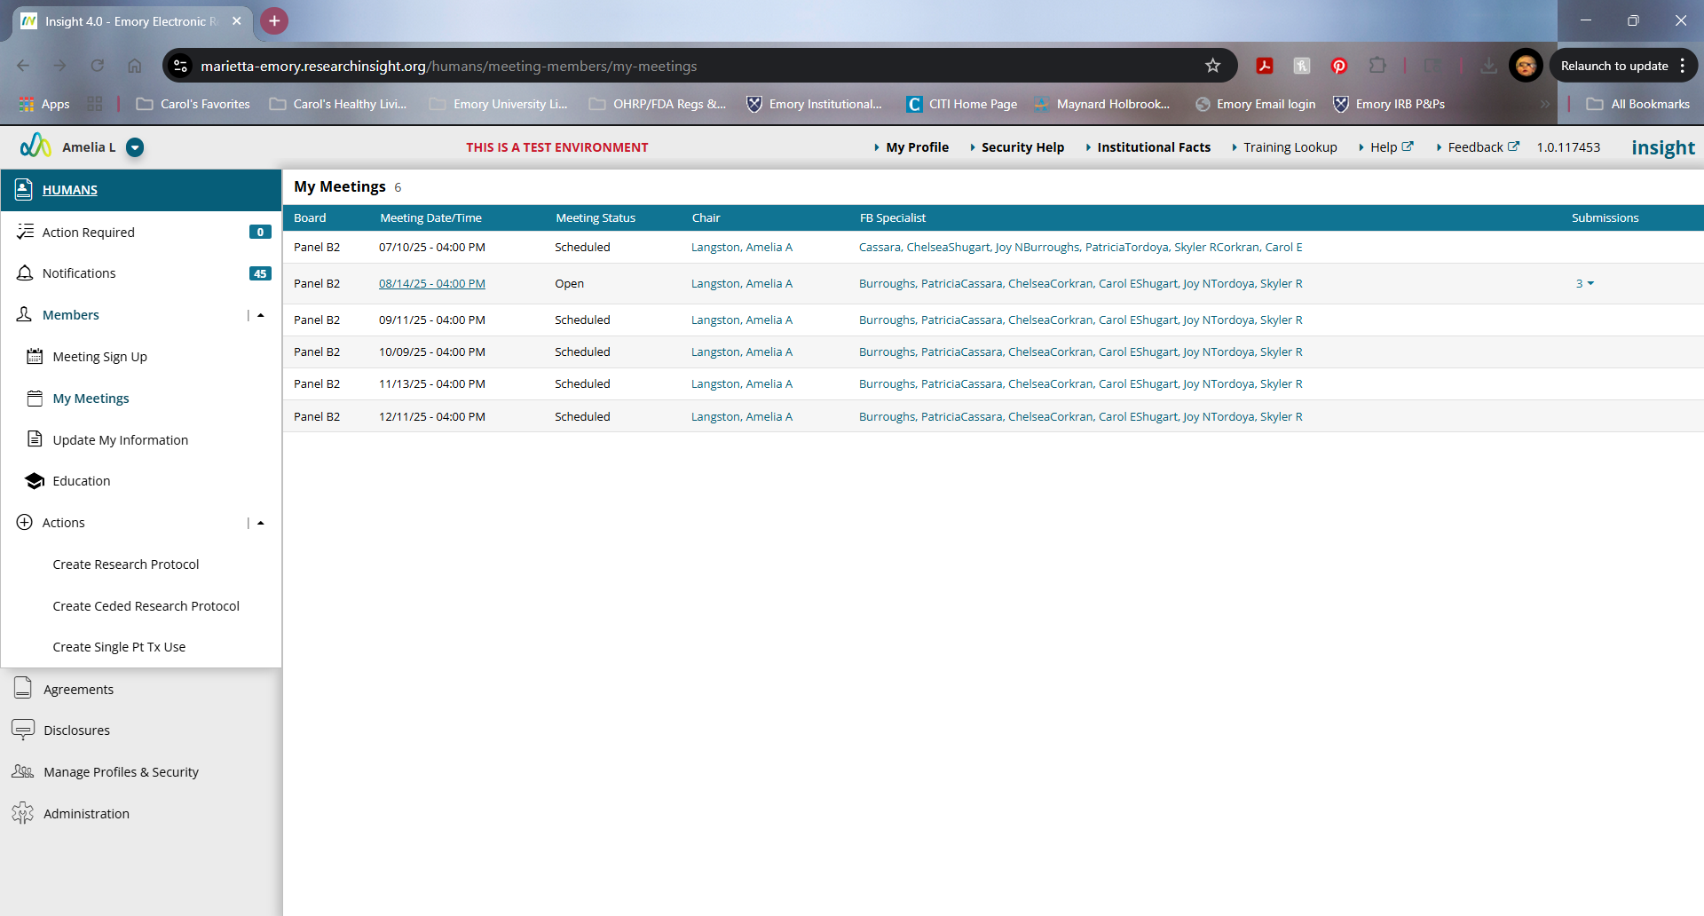
4 | Click on the date of the meeting you are completing your reviews for | Agenda for that scheduled board meeting will populate in lower half of screen. Use the “Scrolling bar” on the right side of the agenda window to see all agenda items assigned to you.  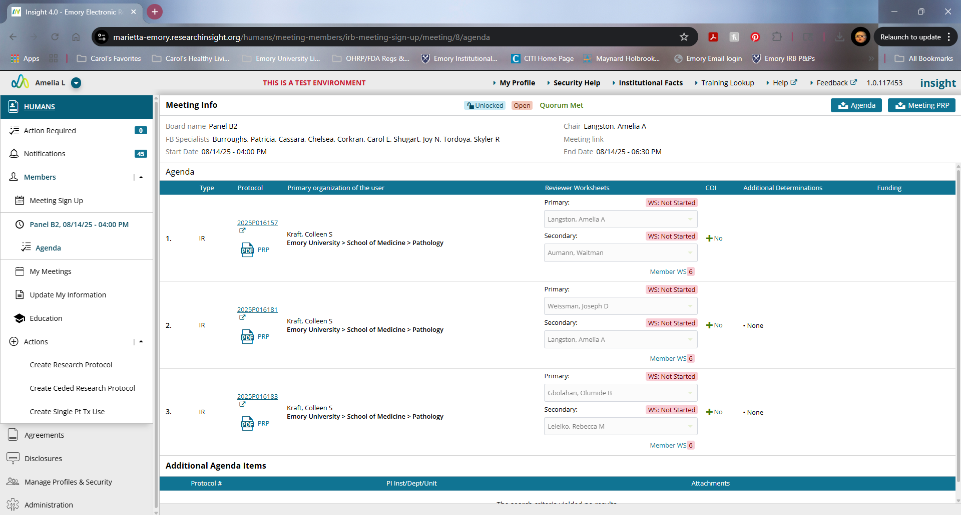
5 | Look for your name as either primary or secondary reviewer under the “Reviewer Worksheets” column. | Should see a pink/red highlighting around “WS: Not Started”
6 | If you have been assigned as a “Tertiary” Reviewer, you will need to click on the blue “Member WS” to access your reviewer worksheet | Select your name in the “Member WS” list.  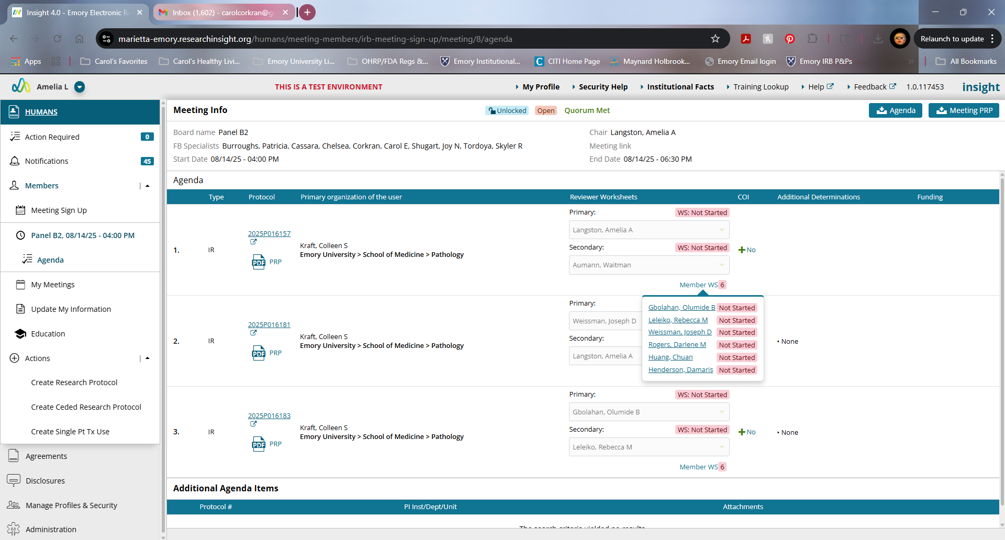
7a | To review the study submission, In the Agenda, you will see a hyperlink to the study ID# under the “Protocol” column. OR follow path in 6b if you prefer to see entire submission in one document. | If you click on the hyperlink of study ID, INSIGHT will take you to the submission workspace. We recommend opening in another web browser tab/window if possible. This path will require you to click “Next” button in lower right-hand corner to proceed through all of the forms that comprise that submission.  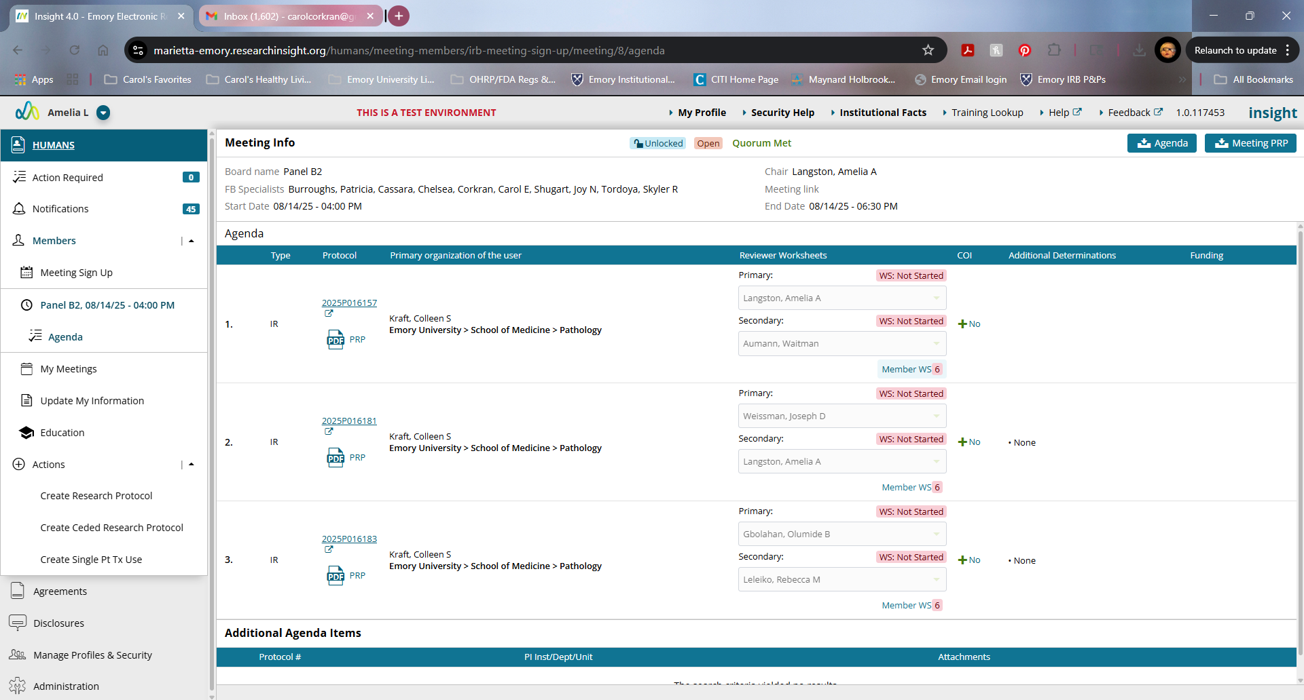  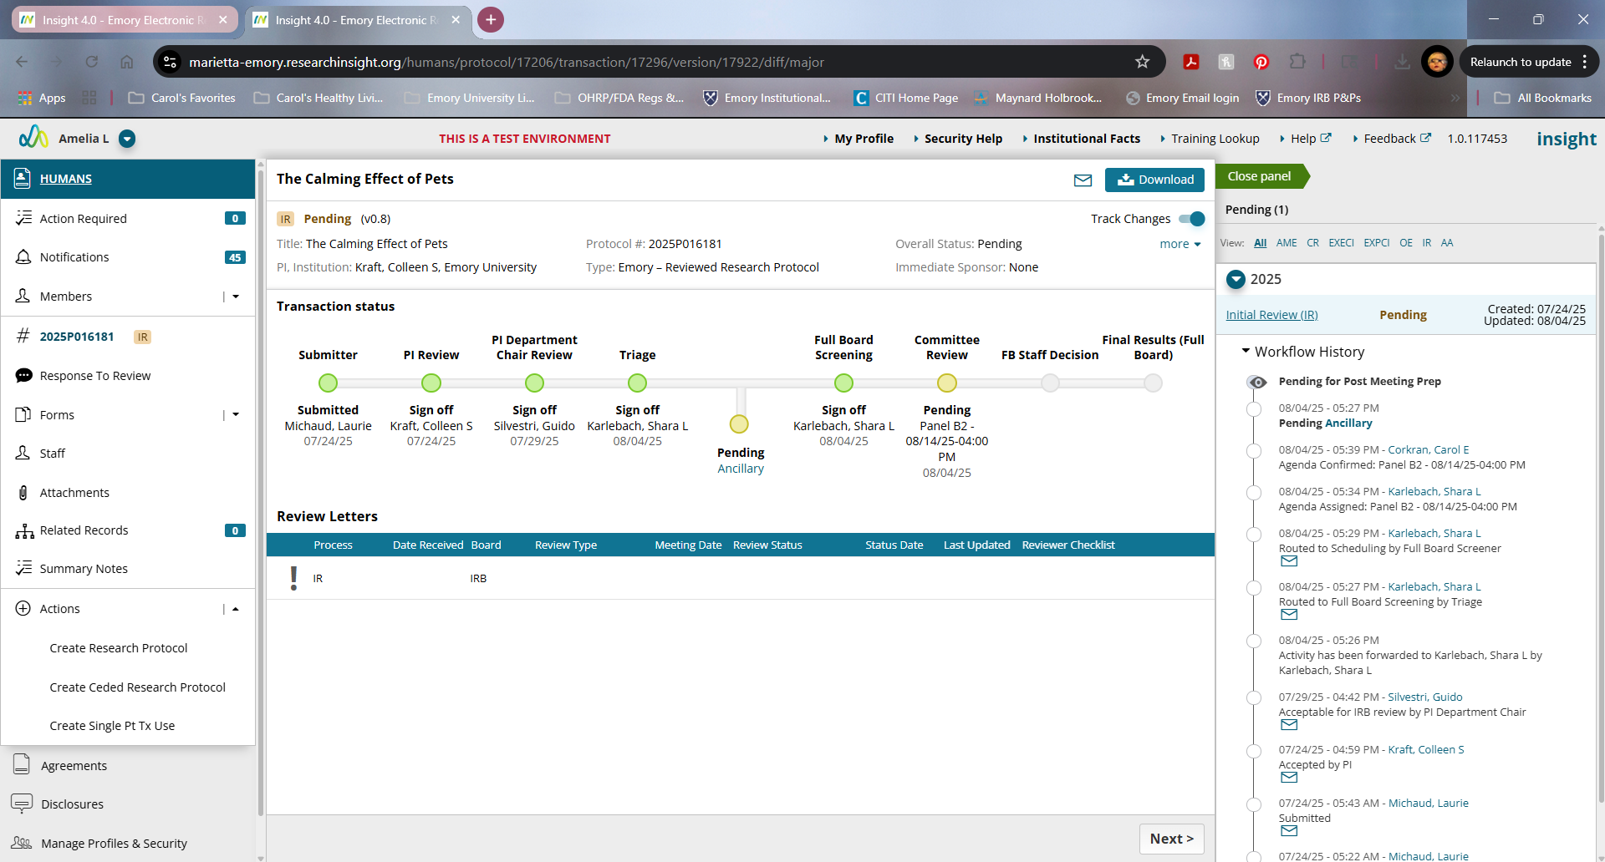  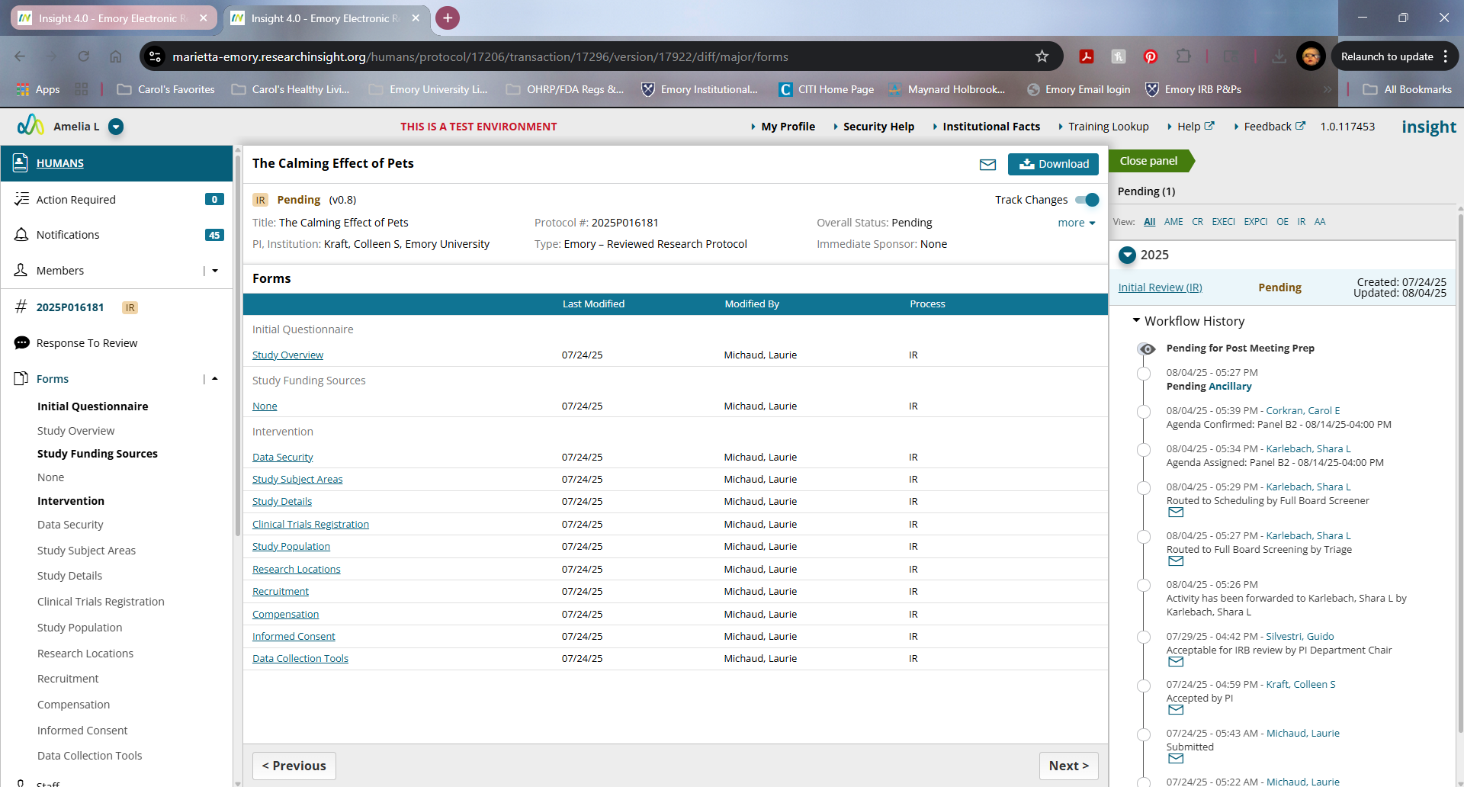
7b | Click on the PDF labeled “PRP” under the study ID# | A PDF of the entire set of forms for that submission will open.  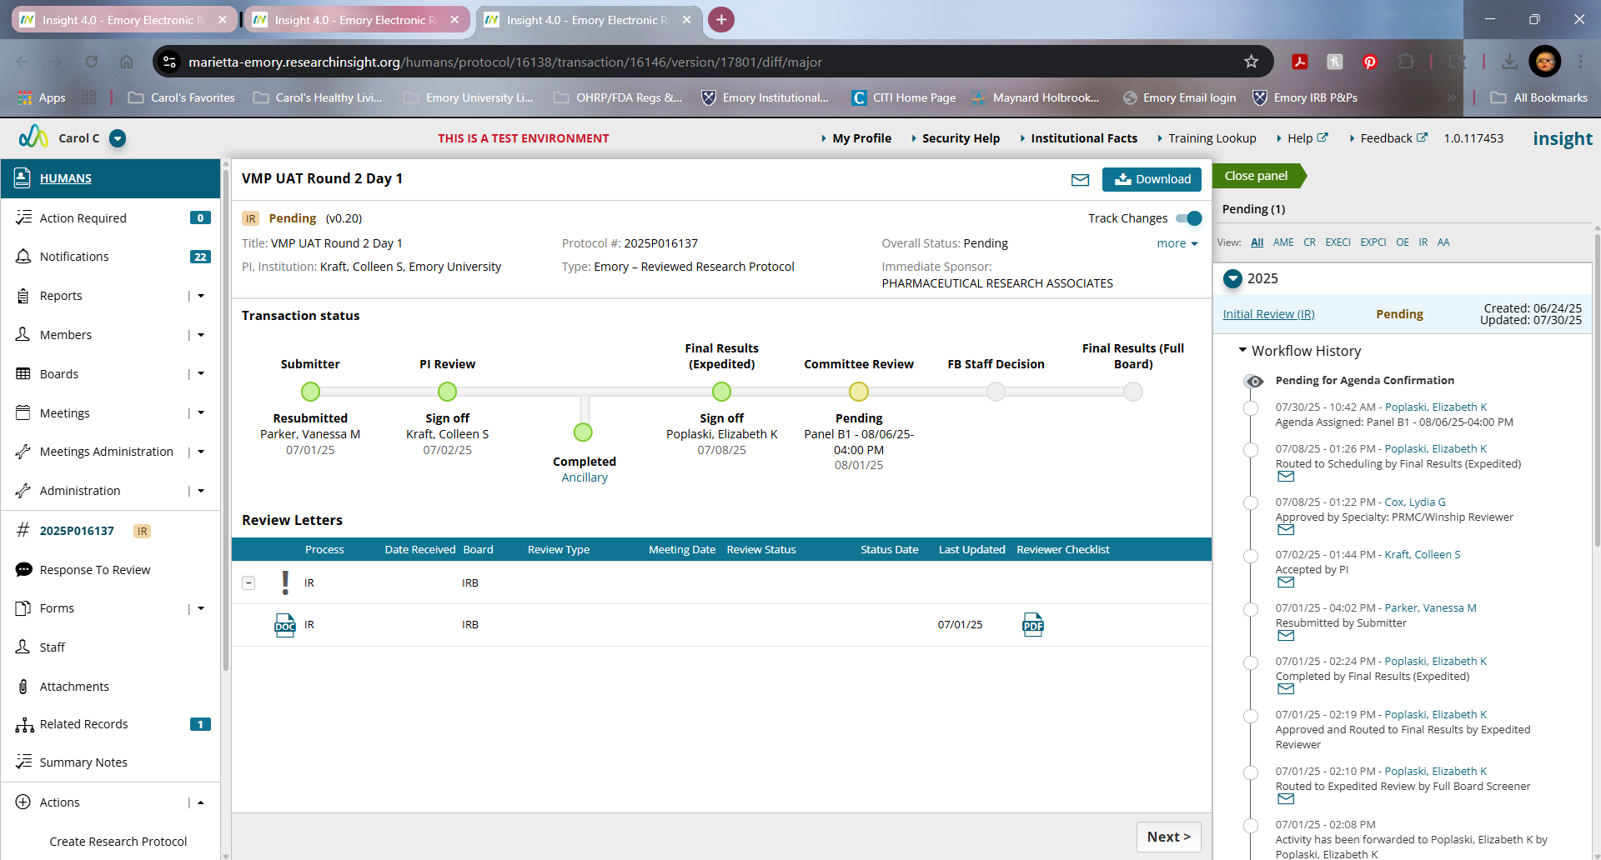  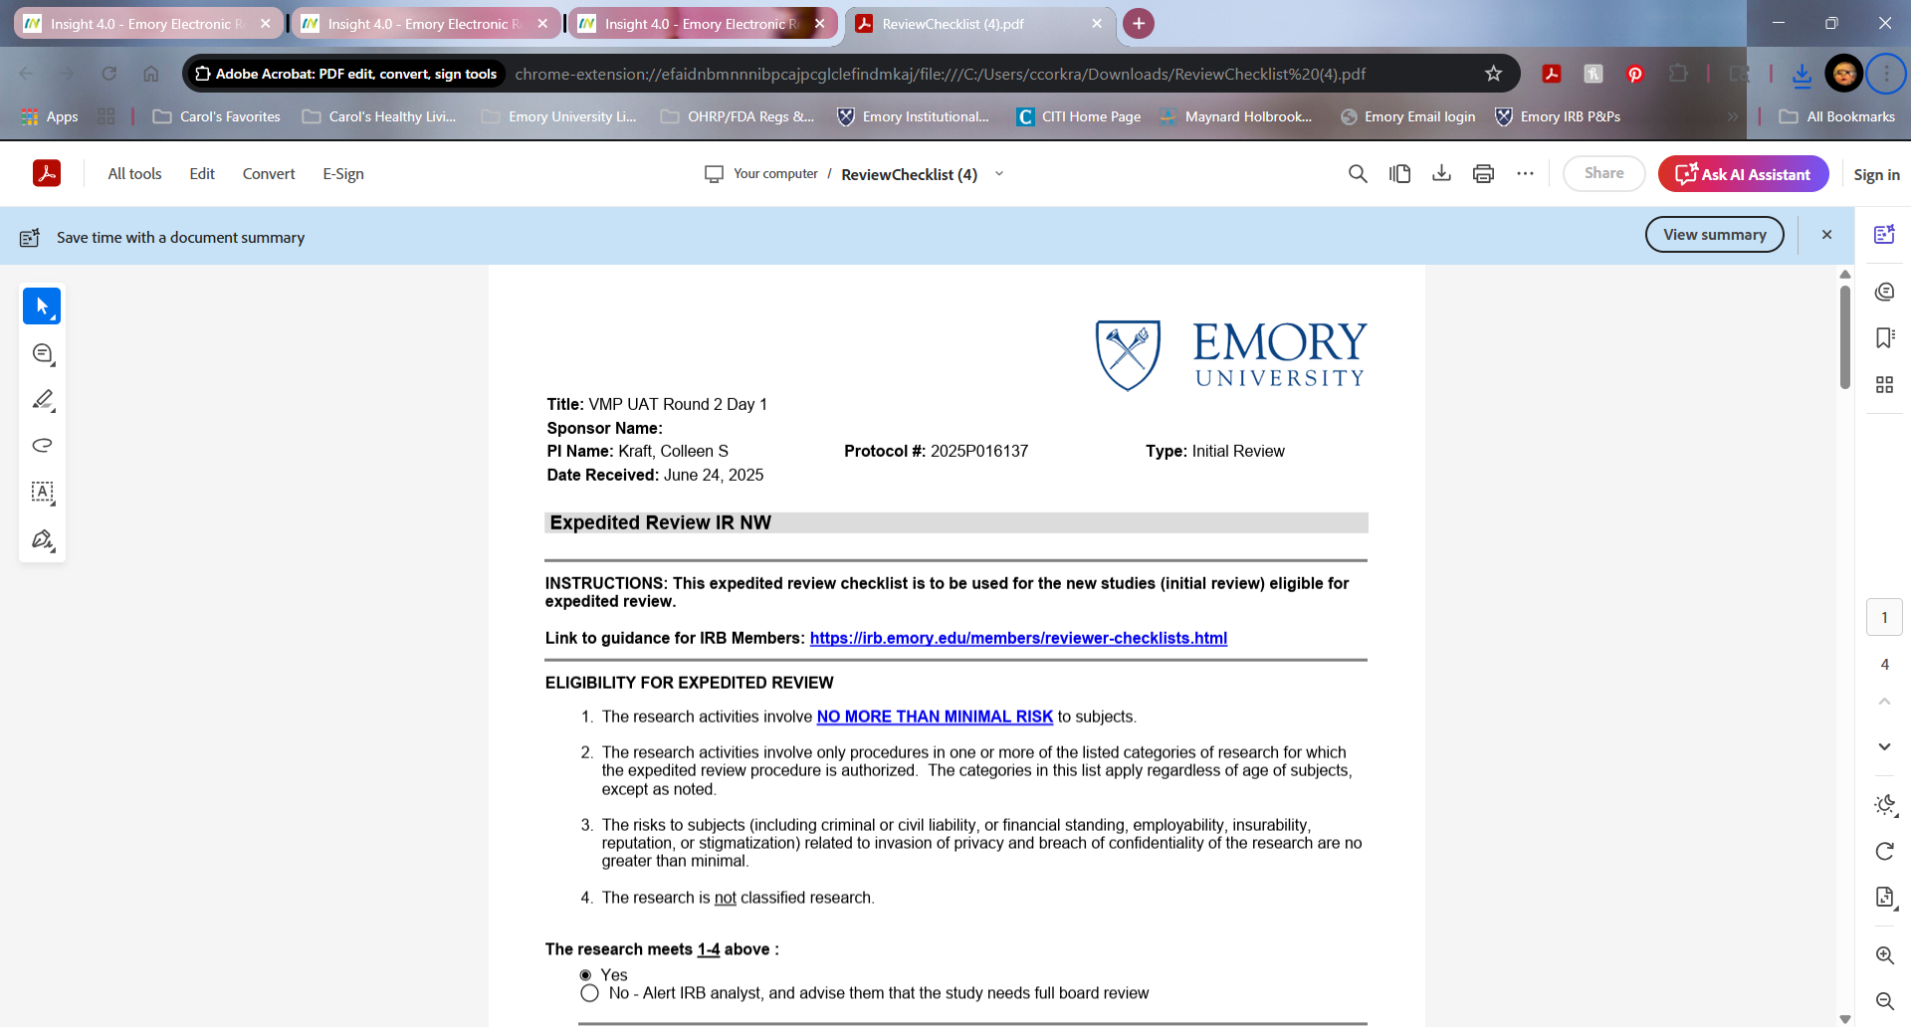
8 | Members need to review all information provided in the INSIGHT forms or PDF to complete WS Reviewer worksheet.  - Each review assigned to you will have a separate Reviewer Worksheet to complete.  - Scroll down and complete each section of the Reviewer Worksheet. | - Please note that there is no study specific information on the Reviewer Worksheet to identify which study you are reviewing, so pay close attention when completing each review.  - The Submission Checklist on the right-hand side of the screen will become shorter as you complete each required section of the Reviewer Worksheet  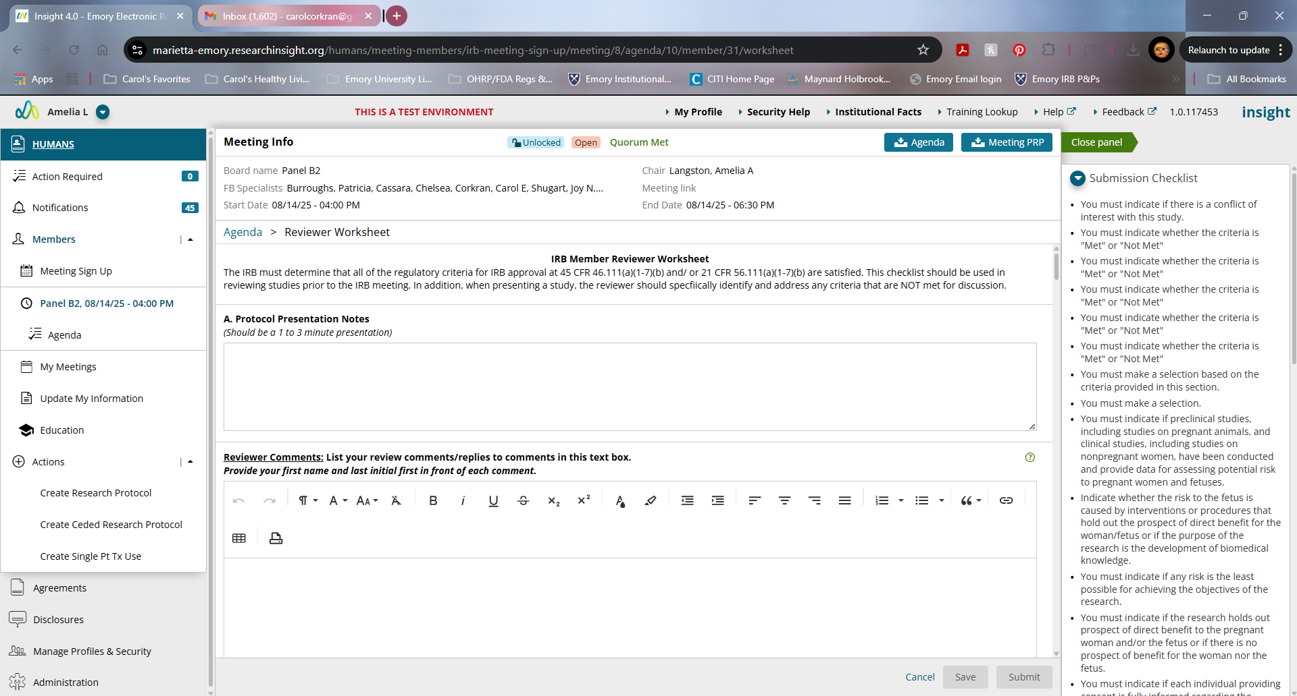
9 | To review Detailed Protocol, Recruitment Materials, Informed Consent/Assent documents, Data Collection tools, Drug/Biologic or Device brochures/manuals, you need to navigate to the “Attachments” form that serves as the final form in the submission. | Should be able to view all documents that the study team has included to be reviewed as part of the IR, CR or AME.  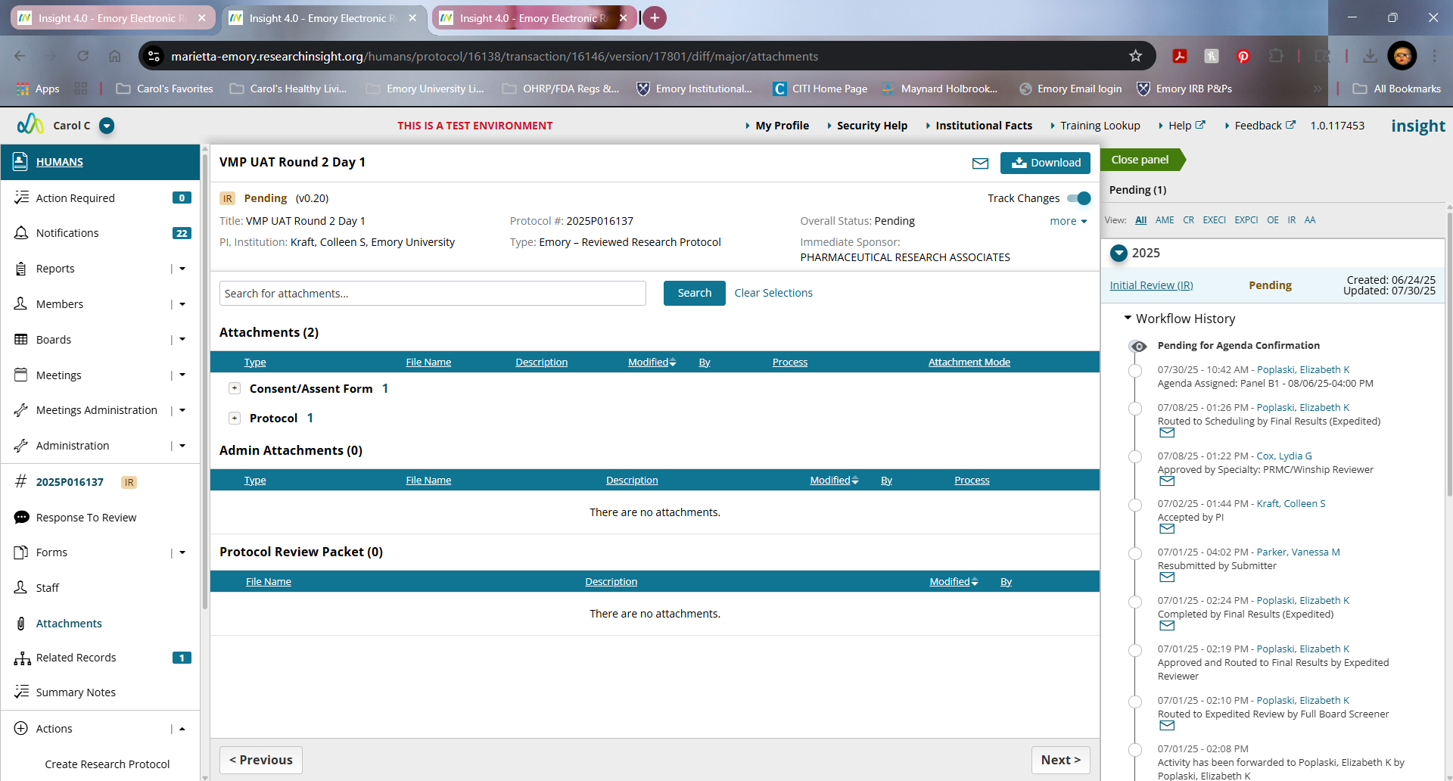

***There are a few different ways to navigate through the INSIGHT forms for each study that we can show you in person.
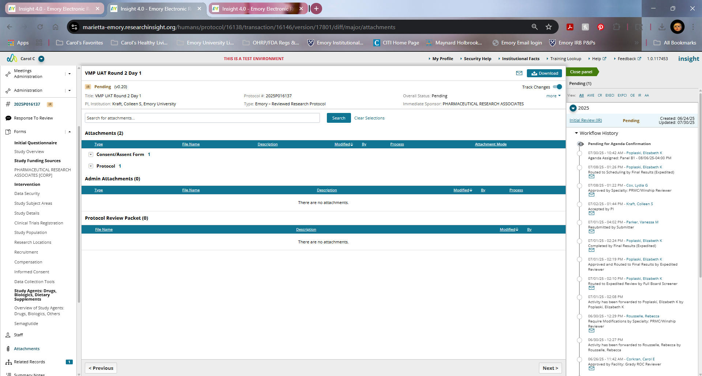OR
