How to Upload Documents to the Attachments Page in Insight
The Emory Institutional Review Board

Instructions for Uploading New Documents
- Create a submission (Research Protocol, Amendment, Continuing Review/Amendment, or Other Event) in the Humans module.
- Fill out the submission form and select the Attachments tab on the left panel.
- A new attachment can be uploaded by:
  - Dragging and dropping the document onto the light green area as shown below. This can be done while another window is open at the same time.
  - Click “select files from computer,” navigate to the location on your computer where the document exists and select the document.
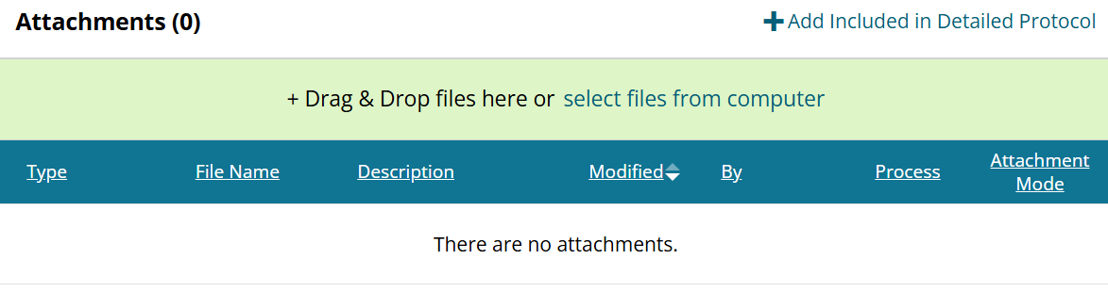
- Once the file is uploaded, select the attachment type from the dropdown menu (Detailed Protocol, Consent/Assent Form, Recruitment Material, Survey/Questionnaire/Interview or Focus Group Guide, etc.).
- When you select Consent/Assent Form or Protocol Summary and click “Add Version Name/Date,” a Window will pop up and you will have to enter a version date for the document.
- When you select Detailed Protocol and click “Add Version Name/Date,” a window will pop up and you will have to enter a version name and date.
- The version information provided must match the version information in the actual document.
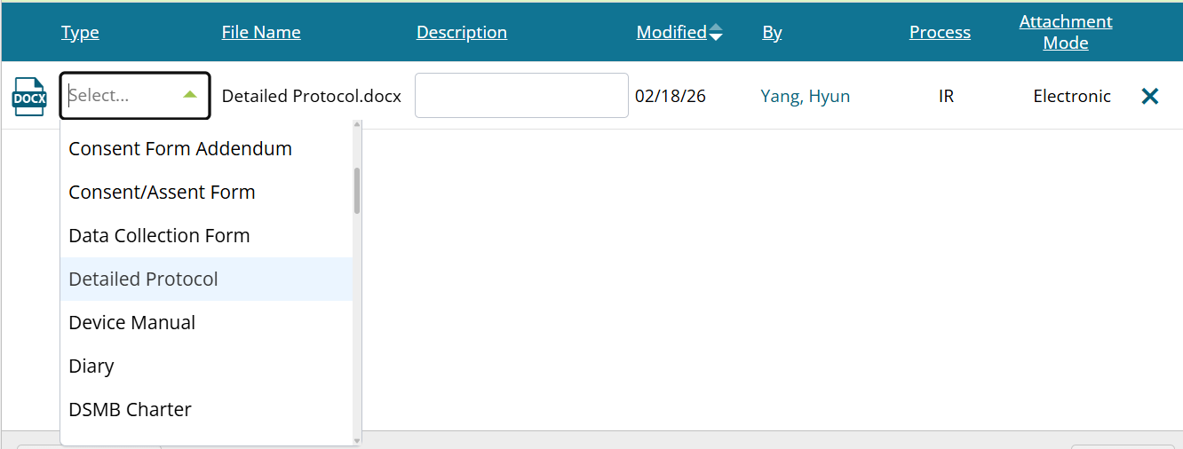
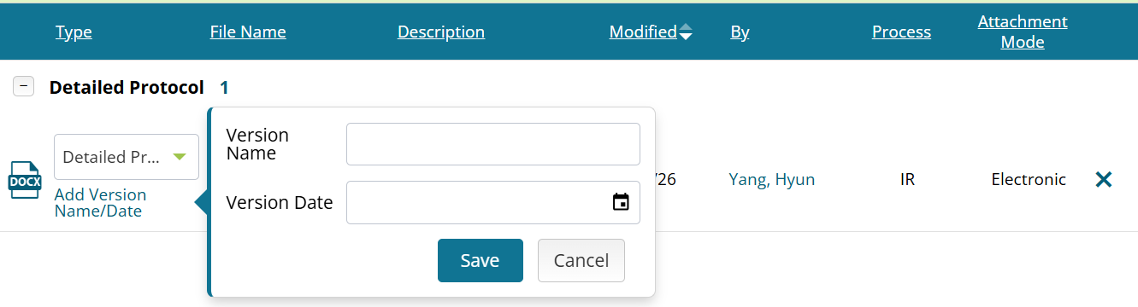
- Add a description.

Instructions for Uploading Revised Documents
- Create a submission (Amendment, Continuing Review/Amendment, or Other Event) in the Humans module.
- Fill out the submission form and select the Attachments tab on the left panel.
- Go to the attachment line for the already existing document you are revising. Download the latest approved version by clicking the document icon on the left side of the attachment line and then revise it. Do not use versions saved to a computer outside of Insight, including those on shared or personal drives.
  - Consent forms and protocols must be in Microsoft Word document format.
  - If you are working with a migrated study for the first time, ensure that the most recently approved version of the documents you want to revise are uploaded, and each consent form and protocol has a version date.
  - Delete any no-longer-used documents by clicking “x” on the right side of the attachment line (do not do this for documents you are revising).
  - If the IRB staff sends the submission back to you for further revisions to the documents, you will not be able to delete the documents you initially uploaded (the “x” will not appear). Just upload new marked and then clean copies, and Insight will know which are the most recent. Once the submission is approved, only the top-level copy of the revised document will appear in the “Protocol Published Documents” area.
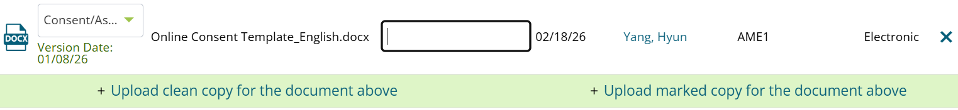
- Once you have revised the document, click “Upload marked copy for the document above” to upload a copy with tracked changes.
- Then click “Upload clean copy for the document above” to upload a clean copy (must be done in this order).
- When you upload a clean/marked copy for Consent/Assent Form or Protocol Summary and click “Add Version Name/Date,” a Window will pop up and you will have to enter a version date for the document.
- When you upload a clean/marked copy for Detailed Protocol and click “Add Version Name/Date,” a window will pop up and you will have to enter a version name and date.
- The version information provided must match the version information in the actual document (on cover page and/or footer).
- Add a description to each attachment line.

