**Task Title:** *Completing a Designated Review*

**Audience:** For IRB staff reviewers and Faculty DRs

**Scope:** For IRB staff or faculty DRs completing a designated review of any type of submission

**Note**: Do not revise forms or the submission while completing a designated review.

|  |  |  |
| --- | --- | --- |
| **Step** | **Action** | **Result/Comments** |
| 1 | Log into [**Insight**](https://emory.researchinsight.org/) and open the ****Humans**** module. |  |
| 2 | Click on **Actions Required** | See the items requiring action |
| 3 | Select the item assigned to you for designated review |  |
| 4 | Review the study  To review the study, you can access it in multiple ways:   * View the forms on the left-hand menu * Download the PDF and view all the forms in a stand-alone PDF * If clarifications are needed, **route to submitter** after making comments on each item needing clarifications. * Once team responds back, this will return to your **Actions Required** and you can view their responses via response to review.   **NOTE**: Each comment must be addressed by the study team before the study team can submit back to the IRB. Once the study is submitted back, click **Response to Review** on the left menu. Select the hyperlink to each form that is listed. Once the form opens, click the red comment bubble which opens the response from the study team. Review each of the responses and confirm the changes requested have been made to the forms or documents. Click the blue “*Reply or Resolve*” button.  If the changes *have been made correctly*, click *Resolved* at the bottom of the comment box. If the requested changes were *not* made, add text to describe the changes still needed and then click *Reply*.  You will need to do this for each comment. Once comments are resolved you can move forward to approval. If further changes are required, you can route back to submitter after replying to the relevant comment.   * If item is ready to approve, select “approve” on the bottom right under actions and complete the **reviewer checklist.** Once complete, mark **approve** and **Route to** **Final Results**, select the IRB analyst in the drop down select reviewer field by selecting the analyst that assigned this to you (you can find that under workflow history) check the attestation box, and click **Sign Off** | See adding comments job aid for reference  Note: When setting **Next Check-In Type** for a Continuing Review: Always select Continuing Review (not Expedited Check-In)  When setting Next Check-In Type for an Initial Review, just follow the instructions on the reviewer checklist. |

**Screenshots:**

Locating reviewer checklist

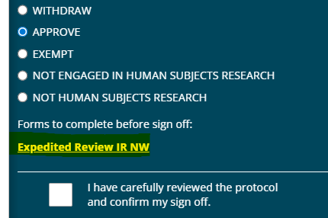

Routing to analyst for letter

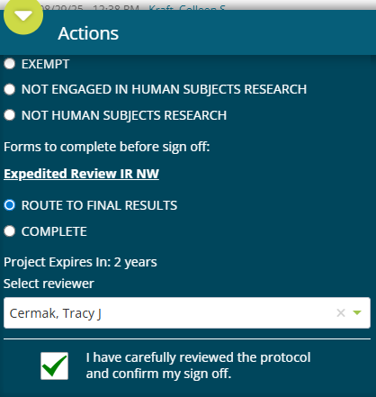

Finding the analyst

