Task Title: Meeting Sign-up
Audience: IRB Members
Scope: Provides instructions on how IRB Members RSVP to attend IRB Committee meetings.
Members will only be able to sign-up for meeting attendance if the meeting schedule is UNLOCKED. Please sign-up for the meetings you are able to attend that quarter of the year. If your meeting schedule is already locked at the time you attempt to RSVP, please contact your Meeting Facilitation Pod so they can administratively edit the meeting attendance to add or remove you from the meeting.
Step | Action | Result/Comments
1 | Log into Insight and open the Humans module. | 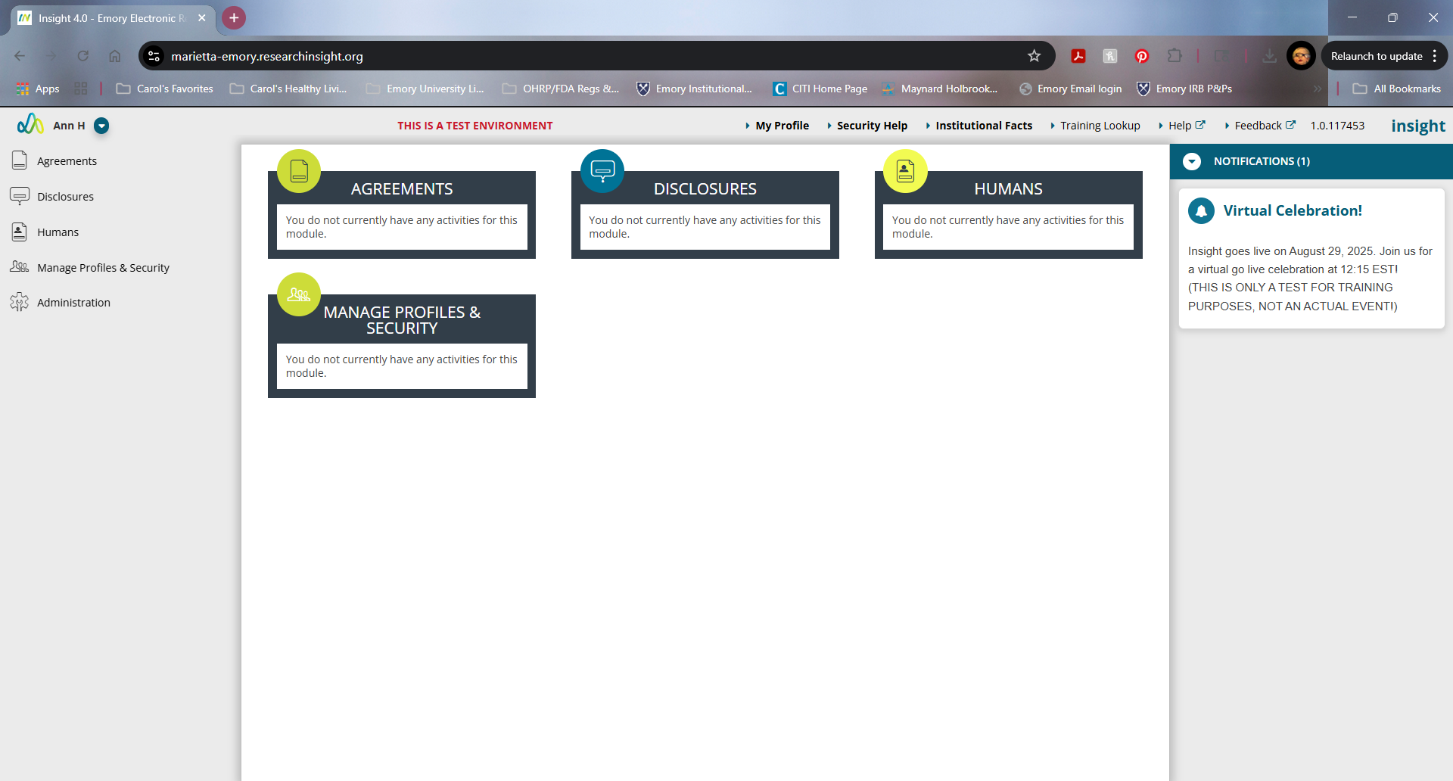
2 | Click on Members on the left menu and then detail | 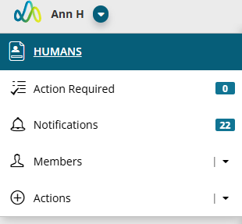
3 | Scroll down to “Meeting Sign-up” and click | Will bring you to a window labeled “Meeting Sign-Up”  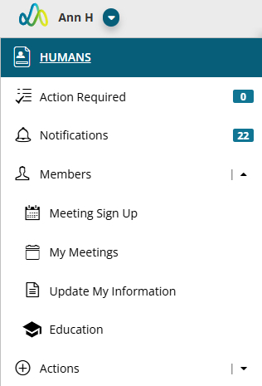
4 | In “Board” name drop-down menu, search for your regularly scheduled committee meeting, (e.g. Panel B1, Panel B2) | “Meeting Sign Up” Calendar for current month. Will also find all of the other scheduled meetings for your panel as you “arrow” through to the following months.  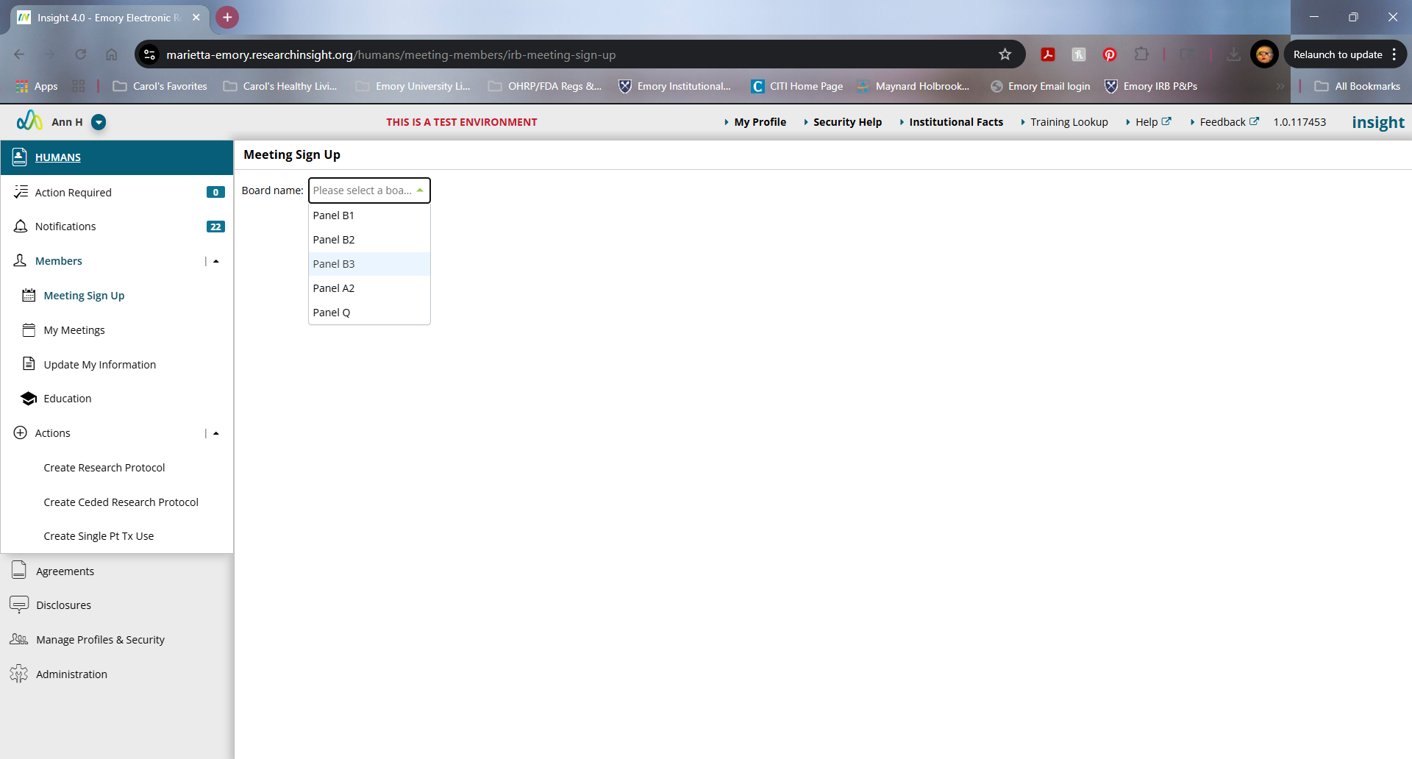  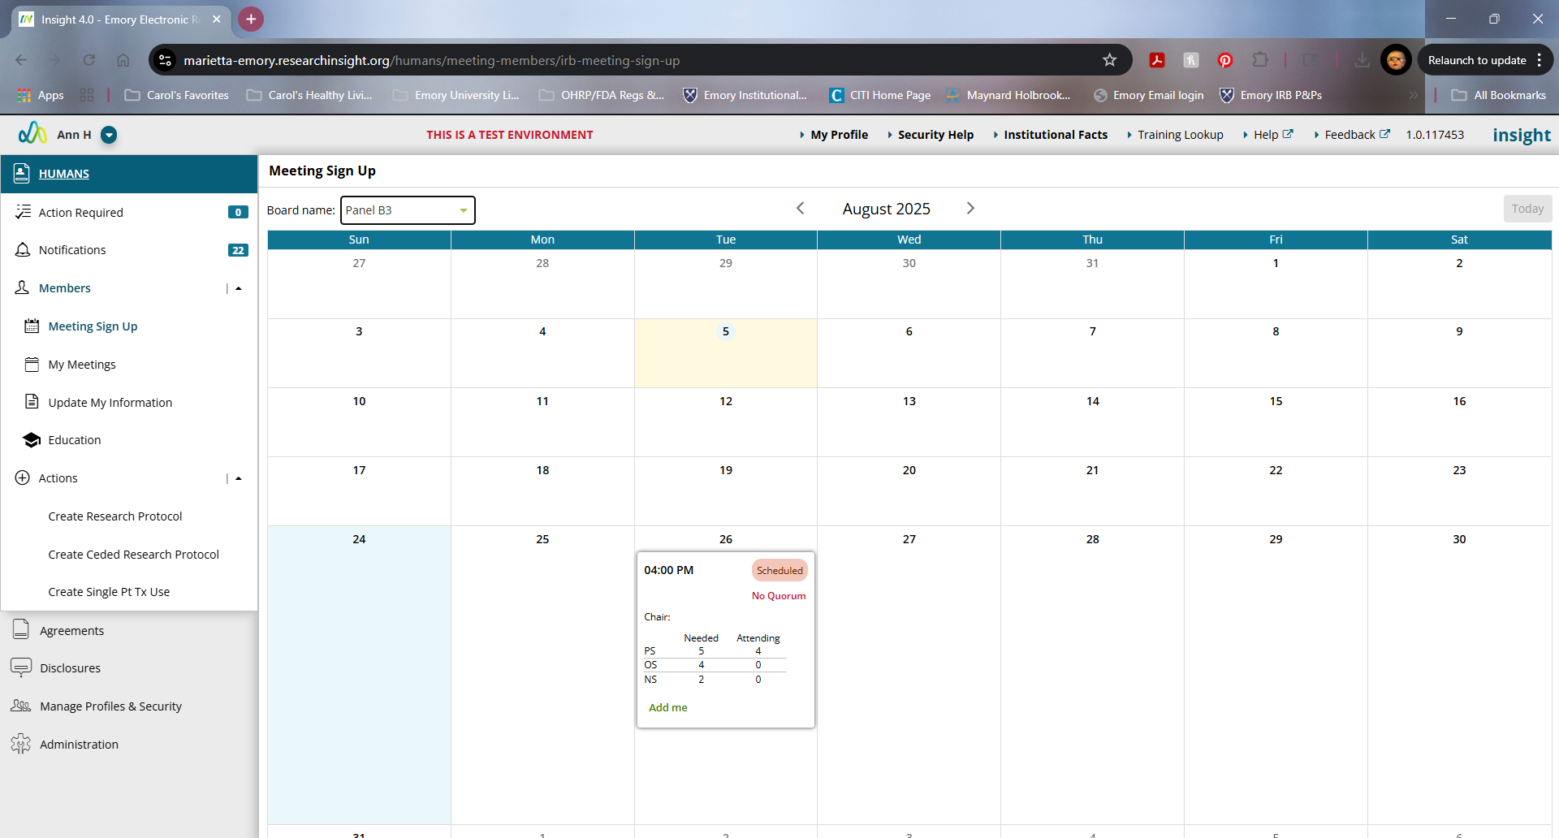
5 | Click on the Add Me in the day the meeting is scheduled. Click “OK” | 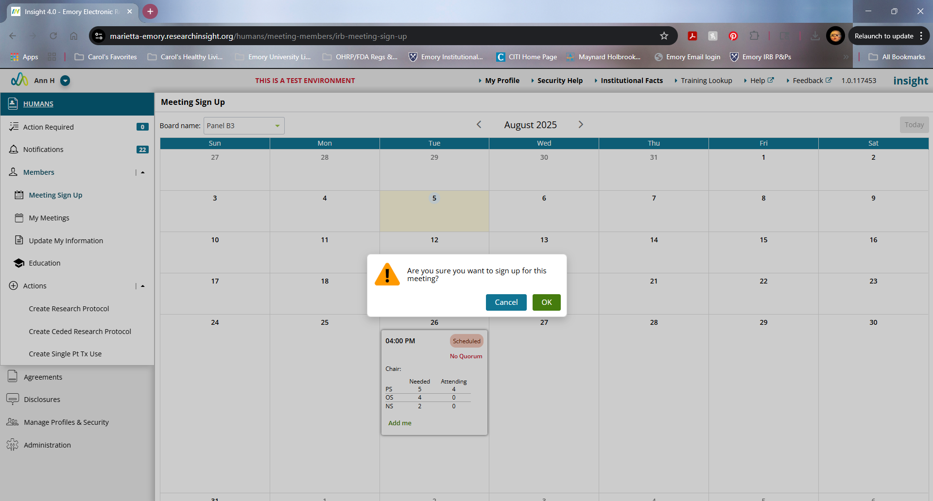  Your RSVP to attend this meeting has been recorded.
6 | To confirm your meeting sign-up, click on “My Meetings” on the left-hand side of screen. | You should see all meetings that you have been scheduled for.  