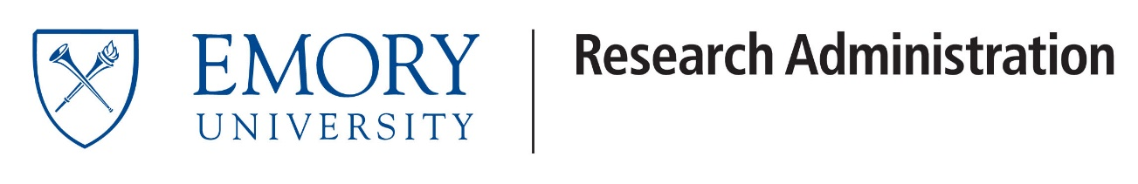

**Date**: October 24, 2024

**To**: Emory Faculty

**From**: Dr. Robert Nobles, VPRA, ORA

**Subject**: Streamlining Sponsor-Investigator Study Start-up

As part of ORA’s continuous effort to streamline research at Emory, we are pleased to announce revised training requirements for new Sponsor-Investigators.

“Sponsor-Investigator” (S-I) refers to an Emory faculty member who holds the IND or IDE for a clinical investigation. This comes with many responsibilities, and thus a need for initial training.

First-time Sponsor-Investigators will now be able to take an online training course in Brainier at their convenience, instead of scheduling a one-on-one meeting. More information can be found here: <https://irb.emory.edu/resources/training/courses.html>.

In addition, the S-I checklist will be a reference tool, and not required as part of study approval. The Emory IRB will verify that FDA Annual Report requirements have been met and will assess Modifications to see if an IND/IDE amendment may be required, eliminating the requirement for annual and ad-hoc review by Research Compliance & Regulatory Affairs (RCRA).

Most importantly, the IRB and RCRA teams will still provide support, consultations and guidance as needed for your IND/IDE related questions. Please see the *Device Studies* and *Drug Studies* sections of RCRA’s website here: <https://rcra.emory.edu/oric/fda/index.html>, as well as the IRB’s Sponsor-Investigator guidance page: <https://irb.emory.edu/guidance/research-types/sponsor-studies.html>.

We look forward to continuing to facilitate the great contributions of our Emory Sponsor-Investigators.

Robert



Robert Nobles, DrPH, MPH

Vice President for Research Administration